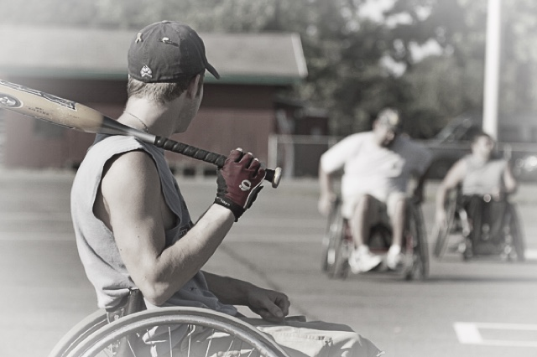  - Saturday MAy 19  Deep south classic  Deep South Classic Wheelchair Softball Tournament  Join us Saturday, May 19, 2018 as Mississippi Society for Disabilities and MACE hosts the 1st Annual Deep South Classic wheelchair softball tournament. Come out and support Your Mississippi Deep South Hurricanes as they take on Team Per4Max of Dallas, Texas and the Nashville National Wheelcats! The winning team will advance to play in the Regional Tournament! The event will be held at the Country Woods Baptist Church in Byram MS! We look forward to you coming out and supporting Your Home Team! | Mississippi’s Only Wheelchair Softball Tournament!  ____  Mississippi’s Home Wheelchair Softball Team: Deep South Hurricanes!  ____  Over 70 players will be participating including teams from Tennessee and Texas!  ____  Winner will advance to Regionals in Nashville TN!  Country Woods baptist church  6737 South Siwell Rd  Byram, MS 39272  www.MSDisabilities.com  May 19, 2018

